PWD:

pwd command writes the full pathname of the current working directory to the standard output.

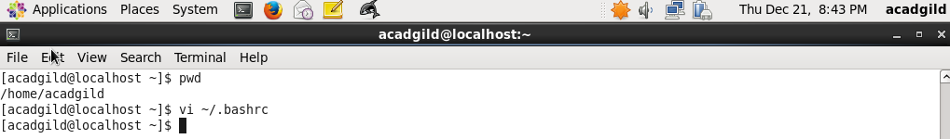

VI:

vi is a screen-oriented text editor originally created for the Unix operating system

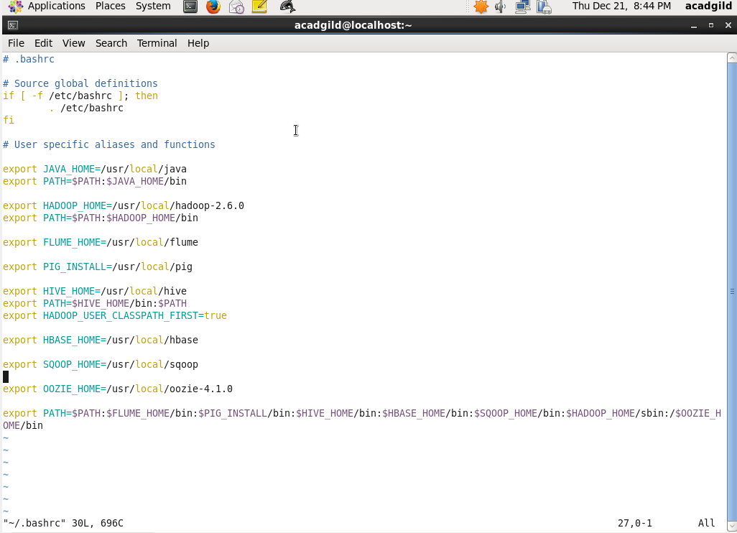

touch:

touch is a standard Unix command-line interface program which is used to update the access date and or modification date of a file or directory

The touch command is the easiest way to create new, empty files. It is also used to change the timestamps (i.e., dates and times of the most recent access and modification) on existing files and directories.

If you just want to create an empty file, you can use the touch command: it creates the file if it doesn't exist, and just updates its last-modified date if it exists.

Touch is used to update the access date and or modification date of a file or directory.

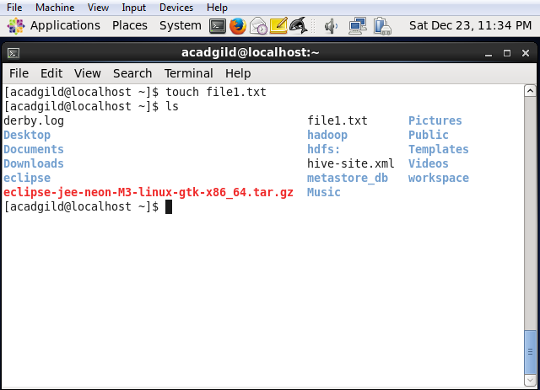

Mkdir: TO create Directory

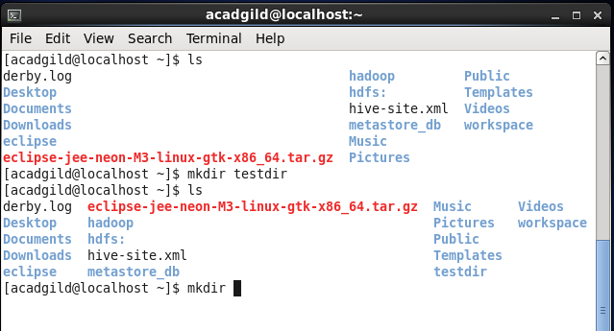

**rm** - remove files or directories

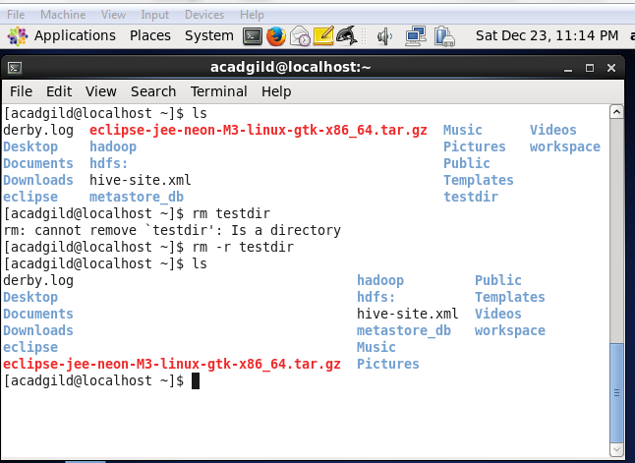

ECHO-In computing, echo is a command in DOS, OS/2, Microsoft Windows, Unix and Unix-like operating systems that outputs the strings it is being passed as arguments.

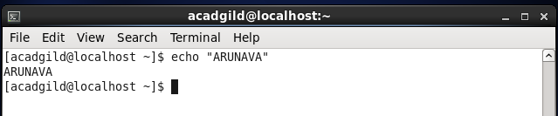

Cat:- cat is a standard Unix utility that reads files sequentially

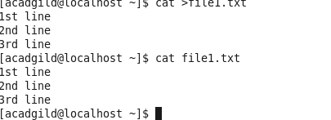

Who:- The standard Unix command who displays a list of users who are currently logged into the computer.

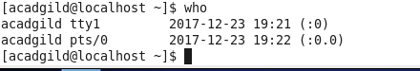

Cd:- The **cd command**, use for change directory

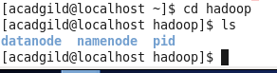

Date:- It will display the current date and time as shown below



Cal:- To display a calendar

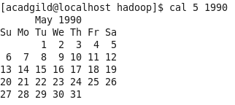

Mv:- mv is a Unix command that moves one or more files or directories from one place to another

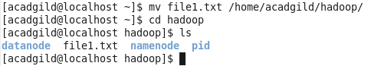

Cp:- cp is a UNIX command for copying files and directories. The command has three principal modes of operation

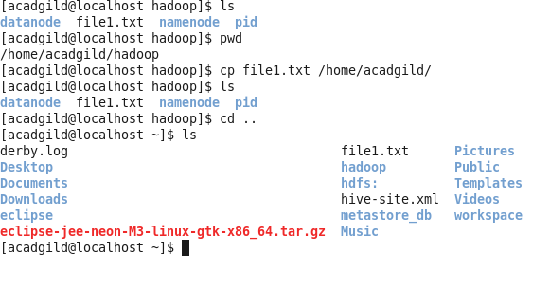

Which:- which is a Unix command used to identify the location of executables.



Ls: list od all the file.

